

Table of Contents

1. Topic 2

2. Authors 2

3. Summary 3

Goal 3

Main stages in accomplishment of the project: 3

Planning 3

Realization 3

Presentation 3

Level of difficulty main problems during realization: 3

Explanation of some of the code: 3

Diagram: 5

4. Explanation of functions 6



# Authors

|  |  |
| --- | --- |
| Name | E-mail |
| Hussein Semir Abumelih | hsabumelih18@codingburgas.bg |
| Teodor Todorov Angelov | ttangelov18@codingburgas.bg |
| Stephan Dnielov Stratev | sdstratev18@codingburgas.bg |
| Alexander Zlatkov Yanev | AZYanev18@codingburgas.bg |

# Topic

The topic of our program is preset, it's a program, which will help students and teachers create teams in which they can work on different projects. The program will be a gateway for them to correspond and interact easily.

# Summary

* + Goal - our goal was to create a useful program that organizes and creates teams.
  + Main stages in accomplishment of the project:

Planning – In this stage, given the fact that we already had a set project, we only had to plan the execution and that is what we did. We made a schedule, distributed the work that had to be done, and started working.

Realization – In this second step we started writing the code of our project and creating the presentation and documentation which explain everything in further detail.

Presentation – The final step is presenting the finished product in front of the judges.

## Level of difficulty main problems during realization:

The most difficult part of completing our project was writing the code for the program. Along the way, we had a few misreadings about the functionality of different parts of the code. We also had a few accidents with the files but in the end, we managed to overcome everything and complete our duties.

## Diagram:

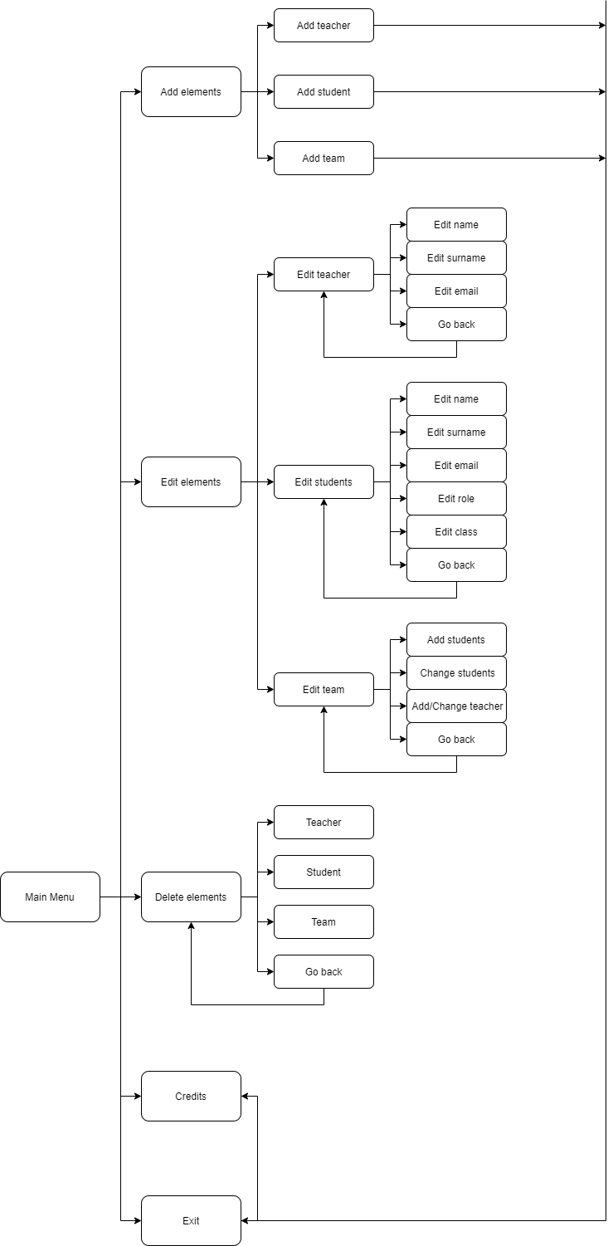

# Explanation of functions

|  |  |  |  |
| --- | --- | --- | --- |
| Function name | Arguments | Purpose | Return value |
| testInt | No arguments | Tests wether the input value is of type integer or not | int |
| menus | int menu, int* choices |  | int |
| addElement | SCHOOL_DATA& schoolData, int* choices | Adds an element to the structure schoolData | void |
| checkInUse | TEAM_STATUS status | Checks if a team is in use | bool |
| showElements | SCHOOL_DATA& schoolData | Shows the teams elements | void |
| enterInfoInFiles | SCHOOL_DATA& schoolData | Enters info in files | void |
| createFiles | SCHOOL_DATA& schoolData | Creates files | void |
| showFileContents | No arguments | Shows the contents of the file | void |
| getTime | No arguments | Shows when the last update was made | string |
| credits | No arguments | Prints out the credits(the creating team) | void |
| deleteElement | SCHOOL_DATA& schoolData, int* choices | Removes an element from a team | void |
| editTeams | SCHOOL_DATA& schoolData | Edits the teams | void |
| teamStatusSwitch | SCHOOL_DATA& schoolData, size_t usedTeamIndex | Switches the status of a team | void |